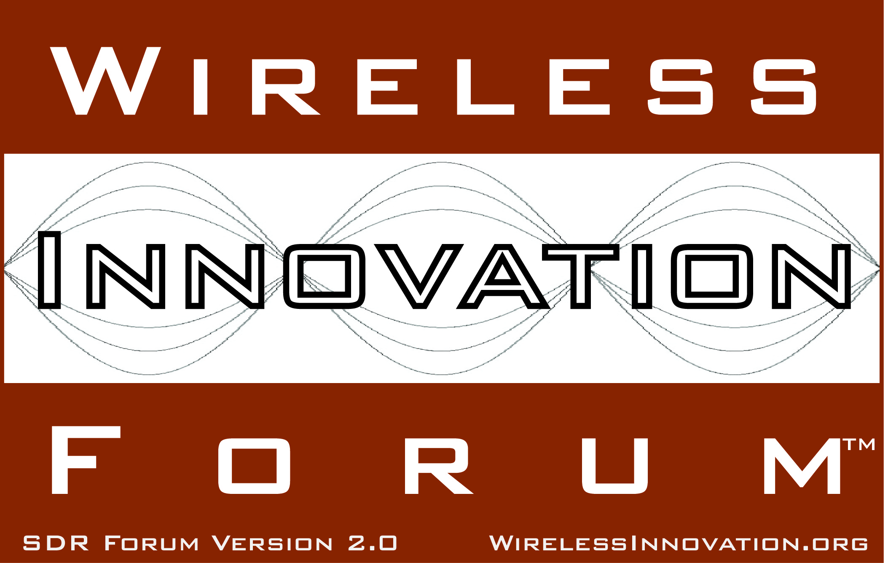

Wireless Innovation Forum adds six new members in first half of 2013

For Immediate Release

WASHINGTON, DC, 22 August 2013 – The Wireless Innovation Forum™ (www.WirelessInnovation.org), a non-profit international industry association dedicated to driving the future of radio communications and systems worldwide, today announced the addition of six new member organizations. These new members bring a broad base of experience in Software Defined Radio (SDR), Cognitive Radio (CR) and Dynamic Spectrum Access (DSA) technologies in diverse markets at levels of the wireless value chain spanning from research labs to telecommunications equipment manufacturers:
Two educational institutions joined:
The mission of Gonzaga University’s Smart Antenna and Radio Lab (SARL) is to create jobs through industry/university cooperative technology development while exposing undergraduate students to opportunities in wireless communications. The lab significantly lowers the product development barrier for new companies by providing access to state of the art measurements, skilled faculty, and students.
Hanyang SDR (Hanyang Software Defined Radio) Research Center, headed by Professor Seungwon Choi, was established by the Ministry of Information and Communication in August 2002. It comprises about a hundred professors and researchers from various universities such as Hanyang, Kyoungbook, Pohang, and Univ. of Wales Swansea. The center pursues the enhancement of SDR technology that flexibly supports implementations of various services (multi-mode/multi-band/multi-function) that correspond to differentstandards of mobile communication technology and wireless LAN systems. A further goal is to improve university research through academy-industry cooperation for developing industrial technology, and for training professionals needed by the industry.
One research organization joined:
Centre for Development of Advanced Computing (C-DAC) is the premier R&D organization of the Department of Electronics and Information Technology (DeitY), Ministry of Communications & Information Technology (MCIT) for carrying out R&D in IT, Electronics and associated areas. As an institution for high-end Research and Development (R&D), C-DAC has been at the forefront of the Information Technology (IT) revolution, constantly building capacities in emerging/enabling technologies and innovating and leveraging its expertise, caliber, skill sets to develop and deploy IT products and solutions for different sectors of the economy, as per the mandate of its parent, the Department of Electronics and Information Technology, Ministry of Communications and Information Technology, Government of India and other stakeholders including funding agencies, collaborators, users and the marketplace.
Three commercial companies joined:
EADS is a global leader in aerospace, defence and related services. In 2012, the Group comprising Airbus, Astrium, Cassidian and Eurocopter generated revenues of 56.5 billion and employed a workforce of over 140,000.
Nutaq is a leader in supplying digital signal processing (DSP) boards, systems, design services and OEM products for the Wireless, Scientific and Defense markets. They develop platforms and solutions incorporating field-programmable gate array (FPGA) and digital signal processing (DSP).
RFEL Ltd was established in 1999 to advance high-speed real-time digital signal processing technology. Since that date, the company has grown rapidly while remaining focussed on using leading-edge hardware and its patented proprietary design techniques, to achieve the real-time video and signal processing performance that is required by today's most advanced defence & security, wireless communications, instrumentation, and video & image applications.
“The Forum is excited to have these new members from various segments of the advanced wireless market participating in our organization,” said Lee Pucker, CEO of the Wireless Innovation Forum. “By joining the Forum, they validate the continuing value the Forum provides to the community in acting as the voice of the SDR, CR and DSA communities, fostering innovation, educating stakeholders, and establishing an ecosystem of interoperable technologies.”
To learn more about membership benefits, and see a current listing of Forum members, visit http://www.WirelessInnovation.org.
# # #
About the Wireless Innovation Forum
Established in 1996, The Wireless Innovation Forum (SDR Forum Version 2.0) is a non-profit mutual benefit corporation dedicated to advocating for spectrum innovation, and advancing radio technologies that support essential or critical communications worldwide. Members bring a broad base of experience in Software Defined Radio (SDR), Cognitive Radio(CR) and Dynamic Spectrum Access (DSA) technologies in diverse markets and at all levels of the wireless value chain to address emerging wireless communications requirements. To learn more about The Wireless Innovation Forum, its meetings and membership benefits, visit www.WirelessInnovation.org.

Editorial Contacts
Lee Pucker, 604-828-9876, Lee.Pucker@wirelessinnovation.org or
Stephanie Hamill, 970-290-9543 or Stephanie.Hamill@wirelessinnovation.org

